**PRE REQUISITE INSTALATION**

**Keywords:**

* Fresh installer- New system installation.
* Patch- smallest modification.
* Upgrader or release- features changes.

**Product Architecture:**

DB MACHINE:

* Redhat machine

CORE MACHINE:

* Redhat machine

SUITE MACHINE:

* Window server machine

**DB MACHINE Pre-Reqs:**

* **Dos2unix**

yum install dos2unix

**CORE MACHINE Pre-Reqs:**

* Zip:

yum install zip

* Unzip

yum install zip

* Dos2unix

yum install dos2unix

**Redis 3.2.3**

* Download redis 3.2.3 from file server

<ftp://192.168.4.232/IRIS5/Pre-Reqs/Core/>

* Now you need to copy this file into vm machine using Winscp

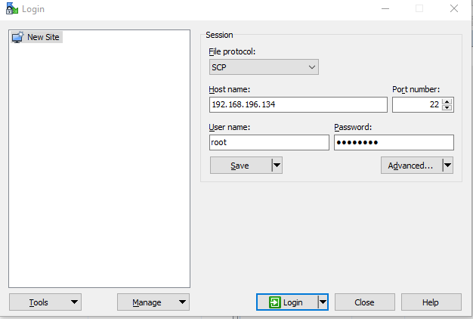

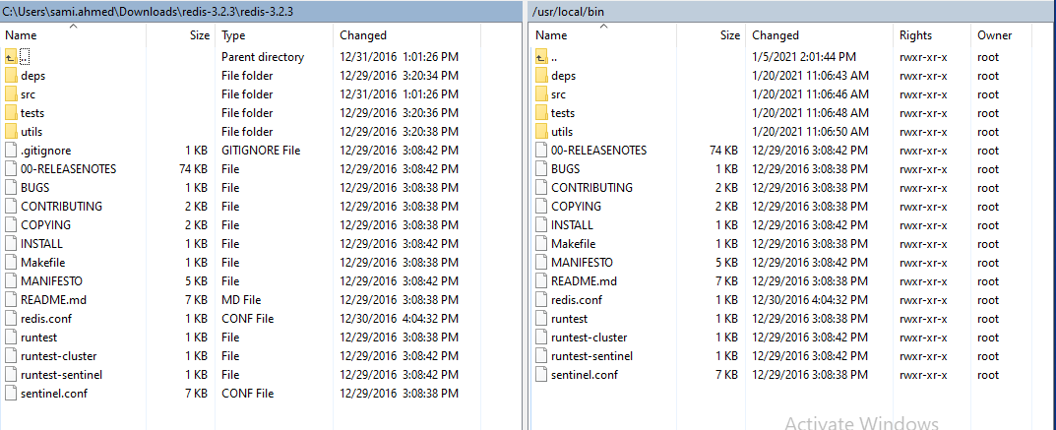

[root@localhost ~]# cd /usr/local/bin

[root@localhost ~]# chmod 755 *

[root@localhost ~]# cd /usr/local/bin/src

[root@localhost src]# chmod 755 *

[root@localhost src]# ./redis-server –port 8999

**Suite machine Pre-Reqs:**

* Putty
* SED
* IIS Web Server
* Oracle client

**Putty Installation:**

* Download exe file from fileserver
* Run exe file
* By default it his path add in environment variable

**SED Installation:**

* Download exe file from fileserver
* Run exe file
* Manually add path add in environment variable through this steps.

**IIS WEB SERVER INSTALLATION:**

* Open Server Manager and click Manage > Add Roles and Features. Click Next.
* Select Role-based or feature-based installation and click next.
* Select the appropriate server. The local server is selected by default. Click Next.
* Enable Web Server (IIS) and click next.
* No additional features are necessary to install the Web Adaptor, so click next.
* On the Web Server Role (IIS) dialog box, click next.
* On the Select role services dialog box, verify that the web server components listed below are enabled. Click Next.
* Verify that your settings are correct and click **Install**.
* When the installation completes, click **Close** to exit the wizard.

**ADD Features:**

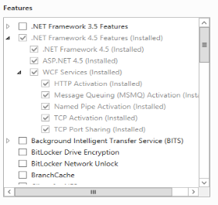

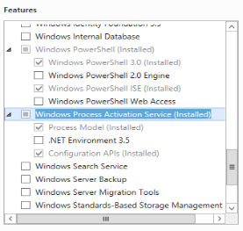

**ADD Roles:**

